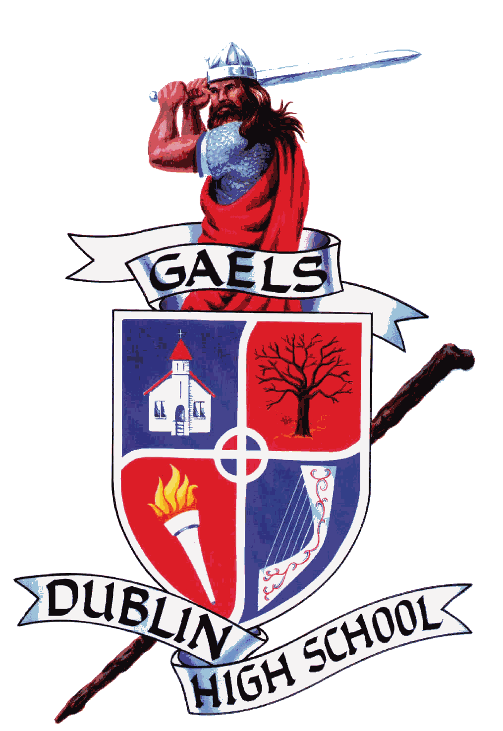
Dublin Music Boosters
President – Tri Ly
Vice President: Paul Dow
Co- Fundraising Chair - Lynne Shinohara
Co- Fundraising Chair: Jean Ryken
Publicity Chair - Davyne Bradley
Secretary – Grace Lutz
Treasurer - Patti Luba
Co-Treasurer- Rhonda Scharton
Band Director – Melissa Williams
Choir Director – Adam Serpa
www.dhsirishguard.org
"The Gael Force"

Dublin High School
Music Booster Meeting Summary

Monday, December 11, 2017 7:00 PM ~ Choir Room
 | Welcome & Call Meeting to Order (1 minute): 7:11PM | Tri Ly, President
 | Secretary's Report (2 minutes)  Presentation of Minutes from last Booster Meeting: November 13, 2017 | Grace Lutz, Secretary
 | Motion to accept the minutes:  Second the motion: | Paul Dow  Sheri Barbier, Liz Crocker, Angela Marotta
 | Director’s Report (3 minutes)  - Unable to Attend | Mr. Serpa – Choir Director
 | Director’s Report (3 minutes)  - Unable to Attend | Ms. Williams – Band/Instrumental Director
 | Treasurer’s Report (10 minutes)  - Presentation of P&L  - $5922 of Butter braids sales  About $300 in costs  - Donations and Commitment for Winter Activities-need commitment in order to purchase music and move forward with the program. Students were given audition music. Board needs to discuss with director. Students need a deadline for commitment. | Patti Luba – Treasurer  Rhonda Scharton- Co-Treasurer
 | Fundraising Report (5 minutes)  - See’s Candies update-Candy handed out tonight, profits @ $1200  - Breakfast with Santa about $600 in photo sales  - Possible Sock Hop spaghetti feed  - Paint & Pint update, profit was $190  - Upcoming Fundraisers: Savers, Jan 6th (10-2pm)& 13th (10-2pm)  - Any new fundraising ideas can be emailed to Lynne and Jean.  Publicity Report (2 minutes)  - FB, Posters/Flyers, Peach Jar, Next door, Dublin Patch, email  - Any issues with getting information?  - New person doing Peach Jar for the District  - Was told to limit the amount of flyers being sent out to the district to larger events only, such as concerts | Lynne Shinohara, Fundraising  Jean Ryken, Co-Fundraising  Davyne Bradley, Publicity
 | President's Report (9 minutes)  - Recognition and Thank you- Kyle Koch  - Sent Thank you card to LDS Church for use of parking lot during Invitational-attempted to give a donation check but respectfully denied as they didn’t want to take away from our program as we are a community to help each other.  - NCPA show, Saturday 2/10/18  - NCPA Meeting, Monday 1/8/18  - Village Appreciation Night, Friday Dec 15^{th,} 7pm Sunshine Saloon in Pleasanton | Tri Ly, President  Paul Dow, Co-President
New Business
- Booster Board Positions/ Committee Chairs
- Chaperone Meeting Wed, Dec 13th
 | Meeting adjourned at: 8:07pm
 | Next Meeting: February 12, 7:00pm Choir room

DHS Music Booster Meeting Sign In
1 | Grace Lutz | 21
2 | Jean Ryken | 22
3 | Tri Ly | 23
4 | Paul Dow | 24
5 | Davyne Bradley | 25
6 | Rhonda Scharton | 26
7 | Patti Luba | 27
8 | Lynne Shinohara | 28
9 | Liz Crocker | 29
10 | Mayumi Berrios | 30
11 | Luis Berrios | 31
12 | Angela Marotta | 32
13 | Sheri Barbier | 33
14 | Leah Villanueva | 34
15 | Tracie Metcalf | 35
16 | Linda Knapp | 36
17 |  | 37
18 |  | 38
19 |  | 39
20 |  | 40

